MEMBER REPORT

ESCAP/WMO Typhoon Committee
41st Session

19 – 24 January 2009
Chiang Mai, Thailand

(MALAYSIA)

 |  | - CONTENTS
 |  |  |  |  | Page
1.0 | Overview of tropical cyclones which have affected/impacted Member’s area since the last Typhoon Committee Session
 | 1.1 | Meteorological Assessment |  |  | 1
 | 1.2 | Hydrological Assessment |  |  | 16
2.0 | Summary of progress in Key Result Areas
 | 2.1 | Reduced Loss of Life from Typhoon-related Disasters
 |  | 2.1.1 | Meteorological Achievements/Results |  | 19
 |  |  | JMA-MMD Storm Surge Model
 |  | 2.1.2 | Hydrological Achievements/Results |  | 20
 |  |  | Improvement of Facilities
 |  | 2.1.3 | Research, Training, and Other Achievements/Results |  | 20
 |  |  | Training Attachment at the Japan Meteorological Agency (JMA)
 | 2.2 | Minimized Typhoon-related Social and Economic Impacts
 |  | 2.2.1 | Meteorological Achievements/Results |  | 21
 |  |  | PRECIS (Providing Regional Climate for Impacts Studies)
 |  | 2.2.2 | Hydrological Achievements/Results |  | 21
 |  |  | Flood Forecasting and Warning (basin in operation)
 |  | 2.2.3 | Disaster Prevention and Preparedness Achievements/ Results |  | 22
 |  | 2.2.4 | Research, Training, and Other Achievements/Results |  | 23
 |  | 2.2.5 | Identified Opportunities/Challenges for Future Achievements/Results |  | 23
 |  |  | PRECIS (Providing Regional Climate for Impacts Studies)
 | 2.3 | Improved Typhoon-related Disaster Risk Management in Various Sectors
 |  | 2.3.1 | Disaster Prevention and Preparedness Achievements/ Results |  | 23
 |  |  | Disaster Management Application System
 |  |  | “999”
 |  |  | Disaster Management and Relief Committee
 |  |  | Reviewing the Directive No. 20 of the National Security Council (NSC)
 |  | 2.3.2 | Research, Training, and Other Achievements/Results |  | 25
 |  |  | Disaster Management Exercise
 |  | 2.3.3 | Regional Cooperation Achievements/Results |  | 26
 |  |  | Regional Cooperation
 | 2.4 | Strengthened Resilience of Communities to Typhoon-related Disasters
 |  | 2.4.1 | Hydrological Achievements/Results |  | 26
 |  |  | Technical Advancement
 |  | 2.4.2 | Disaster Prevention and Preparedness Achievements/ Results |  | 26
 |  |  | National Disaster Relief Trust Fund (NDRF)
 |  | 2.4.3 | Research, Training, and Other Achievements/Results |  | 27
 |  |  | Enhancement of Public Education and Awareness
 |  | 2.4.4 | Regional Cooperation Achievements/Results |  | 27
 |  |  | Third Asian Ministerial Conference on Disaster Risk Reduction
 | 2.5 | Improved Capacity to Generate and Provide Accurate, Timely, and understandable Information on Typhoon-related Threats
 |  | 2.5.1 | Meteorological Achievements/Results |  | 28
 |  |  | Hardware and Software Upgrade
 |  | 2.5.2 | Research, Training, and Other Achievements/Results |  | 28
 |  |  | Research
 |  |  | Training
 |  |  | Information and Communication Technology (ICT)
 |  |  | Surface Observation Station
3.0 | Resource Mobilization Activities |  |  |  | 30
4.0 | Update of Members’ Working Groups representatives |  |  |  | 31

- 1.0 Overview of tropical cyclones which have affected/impacted Member’s area since the last Typhoon Committee Session

1.1 Meteorological Assessment

There are sixteen tropical cyclones (tropical storm intensity or higher) developed over the west Pacific Ocean, South China Sea and Philippines region from 1 September 2007 to 31 December 2007 and another eighteen from 1 January 2008 to 1 November 2008. Table 1 shows the list of the fourteen (14) tropical cyclones that developed over the west Pacific Ocean and two (2) that developed over the northern Philippines region during 1 September 2007 to 31 December 2007. Table 2 shows the list of the ten (10) tropical cyclones that developed over the west Pacific Ocean, five (5) that developed over the Philippines region and three (3) that formed over the South China Sea region during 1 January 2008 to 31 October 2008. Nevertheless, there are only five (5) tropical cyclones from 1 September 2007 to 31 December 2007, and only three (3) from 1 January 2008 to 31 October 2008, as shown in bold in Table 1 and Table 2, which have some impacts on the weather in Malaysia, particularly on the rainfall as well as the coastal waters. The tail effects of these tropical cyclones had enhanced the afternoon convective activities and caused heavy and sometimes widespread rains over Malaysian region. Most of the other tropical cyclones are located far away from Malaysia and have less significant impacts on Malaysia. The tracks of the tropical cyclones that tracked close to Malaysian region are shown in Figure 1 for 1 September 2007 to 31 December 2007 and Figure 2. for 1 January 2008 to 31 October 2008.

The rain cloud clusters over the Malaysian region associated with the tropical cyclones, as shown in the satellite imageries in Figure 3 and Figure 4, indicate heavy and sometimes widespread rains over the region. These heavy and sometimes widespread rains are depicted in the daily rainfall charts of selected meteorological stations from September to November 2007 and May, September and October 2008 as shown in Figures 5a to 5i. Some of these charts may not show significant amount of rainfall as depicted by the corresponding satellite imageries as the heavy rains occurred not over but in the vicinities of these stations.

The number of tropical cyclone advisory issued by the Malaysian Meteorological Department is as shown in Table 3 for 1 September 2007 to 31 December 2007 and Table 4 for 1 January 2008 to 31 October 2008. The tables also shown the starting and ending dates for the advisory issued for each tropical cyclone. There are no tropical cyclone warning issued during both of the periods.

In comparison with previous years, most of this year tropical cyclones are quite a distant away from Malaysia region. They have no significant impacts on the weather over Malaysia. The usually dry, hot and hazy weather conditions during the southwest monsoon season (June to mid-September) had experienced more rainfall. As a result, the usual impacts of the trans-boundary haze pollution over Malaysia region were very much lessened.

Table 1 List of Tropical Cyclones and the date of their Birth, Death and Life Time from 1st September 2007 to 31st December 2007

No. | Tropical Cyclone Name (2007) | Birth | Death | Duration (Days)
1 | Fitow* | 29-Aug-07 | 8-Sep-07 | 10
2 | Danas* | 7-Sep-07 | 11-Sep-07 | 4
3 | Nari* | 13-Sep-07 | 17-Sep-07 | 3
4 | Wipha* | 16-Sep-07 | 19-Sep-07 | 3
5 | Francisco# | 23-Sep-07 | 25-Sep-07 | 1
6 | Lekima# | 30-Sep-07 | 2-Oct-07 | 2
7 | Krosa* | 1-Oct-07 | 8-Oct-07 | 6
8 | Haiyan* | 5-Oct-07 | 6-Oct-07 | 1
9 | Podul* | 5-Oct-07 | 7-Oct-07 | 2
10 | Lingling* | 11-Oct-07 | 15-Oct-07 | 3
11 | Kajiki* | 19-Oct-07 | 22-Oct-07 | 3
12 | Faxai* | 26-Oct-07 | 27-Oct-07 | 1
13 | Peipah* | 3-Nov-07 | 8-Nov-07 | 5
14 | Tapah* | 12-Nov-07 | 12-Nov-07 | 18 Hours
15 | Mitag* | 20-Nov-07 | 27-Nov-07 | 7
16 | Hagibis* | 20-Nov-07 | 27-Nov-07 | 6

Remarks: 1. Tropical cyclones that formed over

* west Pacific Ocean (14 cases)
# Philippines region (2 cases)
@ South China Sea region (0 cases)

2. Tropical cyclones that have impacts on the weather in Malaysia are shown in bold.
Table 2 List of Tropical Cyclones and the date of their Birth, Death and Life Time from 1st January 2008 to 31st October 2008

No. | Tropical Cyclone Name (2008) | Birth | Death | Duration (Days)
1 | Neoguri@ | 15-Apr-08 | 19-Apr-08 | 4
2 | Rammasun* | 7-May-08 | 13-May-08 | 5
3 | Matmo# | 15-May-08 | 17-May-08 | 1
4 | Halong@ | 16-May-08 | 20-May-08 | 4
5 | Nakri* | 27-May-08 | 3-Jun-08 | 7
6 | Fengshen* | 19-Jun-08 | 25-Jun-08 | 6
7 | Kalmaegi# | 15-Jul-08 | 20-Jul-08 | 5
8 | Fung-Wong* | 25-Jul-08 | 29-Jul-08 | 4
9 | Kammuri# | 5-Aug-08 | 7-Aug-08 | 2
10 | Phanfone* | 10-Aug-08 | 11-Aug-08 | 1
11 | Vongfong* | 15-Aug-08 | 17-Aug-08 | 2
12 | Nuri* | 18-Aug-08 | 23-Aug-08 | 5
13 | Sinlaku# | 8-Sep-08 | 21-Sep-08 | 12
14 | Hagupit* | 19-Sep-08 | 25-Sep-08 | 5
15 | Jangmi* | 24-Sep-08 | 1-Oct-08 | 6
16 | Mekkhala@ | 29-Sep-08 | 30-Sep-08 | 1
17 | Higos# | 30-Sep-08 | 4-Oct-08 | 4
18 | Bavi* | 19-Oct-08 | 20-Oct-08 | 1

Remarks: 1. Tropical cyclones that formed over

* west Pacific Ocean (10 cases)
# Philippines region (5 cases)
@ South China Sea region (3 cases)

2. Tropical cyclones that have impacts on the weather in Malaysia are shown in bold.

Table 3 Number of Tropical Cyclone Advisory Issued from 1st September 2007 to 30thNovember 2007

No. | Name | Category | Advisory Issued | Start Date |  | End Date
1 | Francisco | Storms | 7 | 23/09/2007 | - | 25/09/2007
2 | Lekima | Typhoon | 6 | 02/10/2007 | - | 04/10/2007
 |  | Storms | 8 | 30/09/2007 | - | 04/10/2007
3 | Krosa | Typhoon | 13 | 04/10/2007 | - | 07/10/2007
 |  | Storms | 6 | 05/10/2007 | - | 09/10/2007
4 | Peipah | Typhoon | 8 | 05/11/2007 | - | 07/11/2007
 |  | Storms | 11 | 04/11/2007 | - | 09/11/2007
5 | Hagibis | Typhoon | 8 | 22/11/2007 | - | 23/11/2007
 |  | Storms | 12 | 19/11/2007 | - | 21/11/2007
6 | Mitag | Typhoon | 10 | 24/11/2007 | - | 27/11/2007
 |  | Storms | 5 | 27/11/2007 | - | 28/11/2007

Table 4 Number of Tropical Cyclone Advisory Issued from 1st January 2008 to 31st October 2008

No. | Name | Category | Advisory Issued | Start Date |  | End Date
1 | Neoguri | Typhoon | 11 | 16/04/2008 | - | 19/04/2008
 |  | Storms | 6 | 16/04/2008 | - | 20/04/2008
2 | Rammasun | Typhoon | 10 | 08/04/2008 | - | 10/04/2008
 |  | Storms | 7 | 09/04/2008 | - | 12/04/2008
3 | Halong | Typhoon | 1 | 17/05/2008 | - | -
 |  | Storms | 8 | 17/05/2008 | - | 18/05/2008
4 | Fengshen | Typhoon | 8 | 20/06/2008 | - | 22/06/2008
 |  | Storms | 10 | 19/06/2008 | - | 24/06/2008
5 | Fung Wong | Typhoon | 5 | 27/07/2008 | - | 28/07/2008
 |  | Storms | 3 | 28/07/2008 | - | 29/07/2008
6 | Kammuri | Storms | 14 | 04/08/2008 | - | 07/08/2008
7 | Nuri | Typhoon | 9 | 19/08/2008 | - | 22/08/2008
 |  | Storms | 8 | 19/08/2008 | - | 23/08/2008
8 | 14 W | Storms | 4 | 27/08/2008 | - | 28/08/2008
9 | Sinlaku | Typhoon | 12 | 09/09/2008 | - | 13/09/2008
10 | Hagupit | Typhoon | 9 | 20/09/2008 | - | 24/09/2008
 |  | Storms | 8 | 22/09/2008 | - | 24/09/2008
11 | Jangmi | Typhoon | 14 | 25/09/2008 | - | 29/09/2008
 |  | Storms | 6 | 29/09/2008 | - | 01/10/2008
12 | Makkhala | Typhoon | 1 | 29/09/2008 | - | 29/09/2008
 |  | Storms | 6 | 29/09/2008 | - | 01/10/2008
13 | Higos | Typhoon | 1 | 01/10/2008 | - | 01/10/2008
 |  | Storms | 13 | 30/09/2008 | - | 05/10/2008
14 | 22W | Storms | 2 | 14/10/2008 | - | 05/10/2008

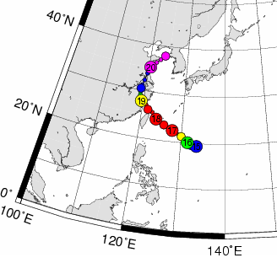 |  | 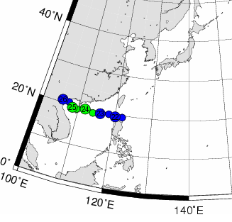
WIPHA |  | FRANCISCO
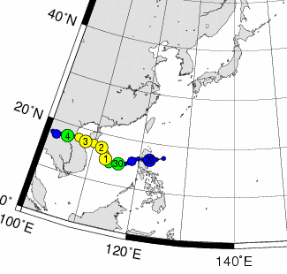 |  | 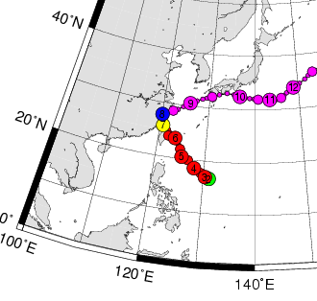
LEKIMA |  | KROSA
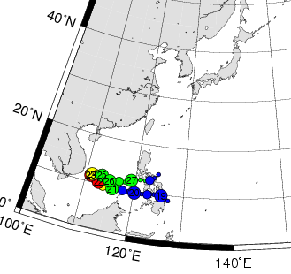
HAGIBIS

Figure 1 Tracks of the five (5) tropical cyclones closest to Malaysia during 1 September 2007 to 31 December 2007. The number in the circle represents the date of occurrence of the tropical cyclones.

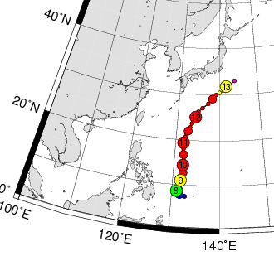 |  | 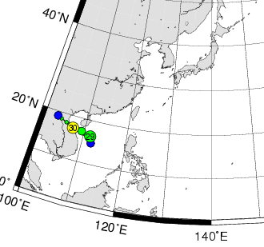
RAMMASUN |  | MEKKHALA
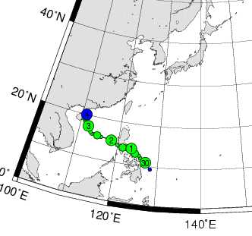
HIGOS

Figure 2 Tracks of the three (3) tropical cyclones closest to Malaysia during 1 January 2008 to 31 October 2008. The number in the circle represents the date of occurrence of the tropical cyclones.

Wipha (16/09/2007) Francisco (23/09/2007)

Lekima (30/09/2007) Krosa (06/10/2007)

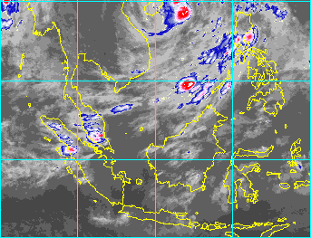
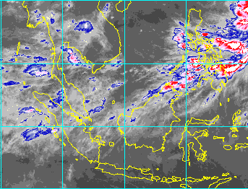
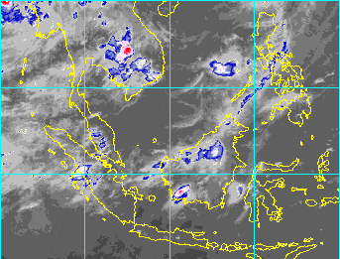

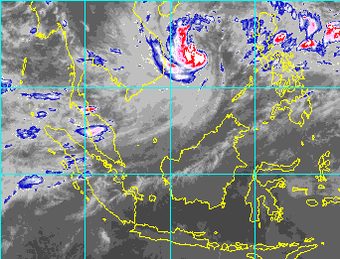
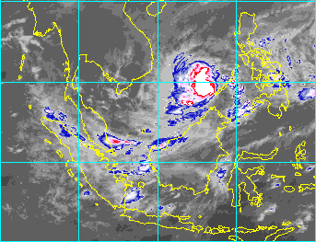

Hagibis (21/11/2007)

Figure 3 Satellite Imageries indicate the rain cloud clusters associated with some of the selected tropical cyclones over the Malaysian region during 1 September 2007 to 31 December 2007.

Rammasun (09/05/2008) Mekkhala (29/09/2008)

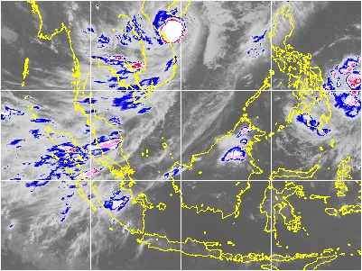
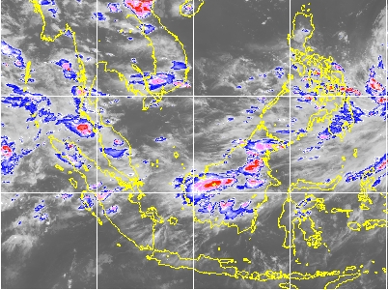

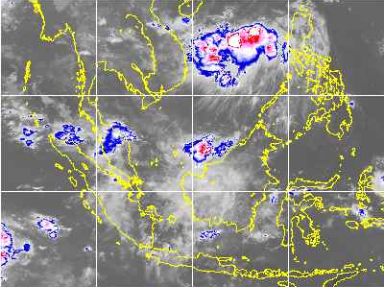

Higos (02/10/2008)

Figure 4 Satellite Imageries indicate the rain cloud clusters associated with some of the selected tropical cyclones over the Malaysian region during 1 January 2008 to 1 November 2008.

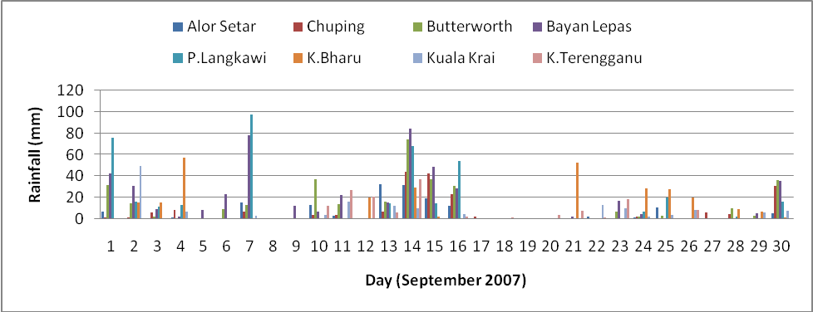
Figure 5a Daily rainfall chart recorded by selected meteorological stations in Peninsular Malaysia for September 2007: Tropical Storm Francisco (23/9/07-25/9/07) and Severe Tropical storm Lekima (30/09/07-02/10/07).

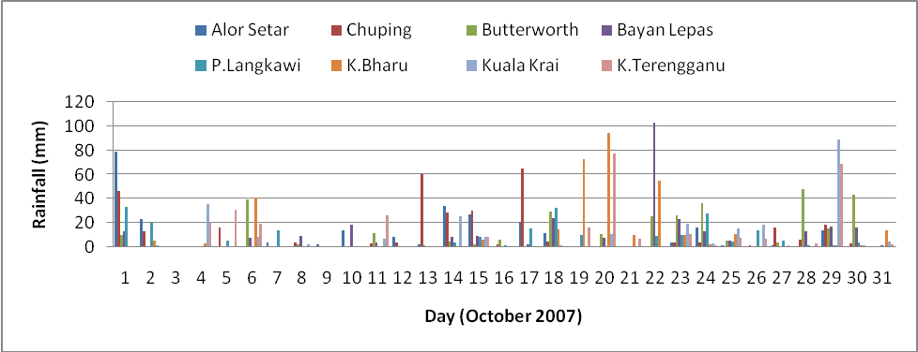

Figure 5b Daily rainfall chart recorded by selected meteorological stations in Peninsular Malaysia for October 2007: Typhoon Krosa (1/10/07-08/10/07).

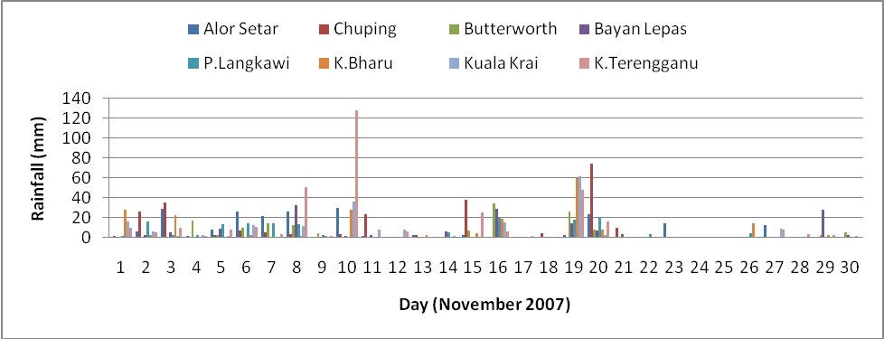

Figure 5c Daily rainfall chart recorded by selected meteorological stations in Peninsular Malaysia for November 2007: Typhoon Hagibis (20/11/07-27/11/07).

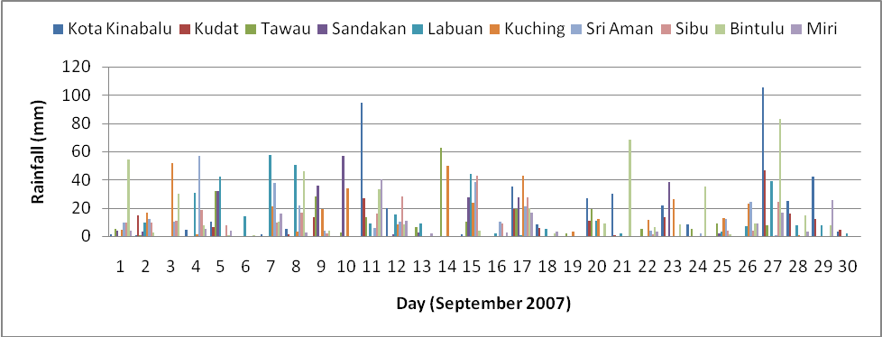

Figure 5d Daily rainfall chart recorded by selected meteorological stations in East Malaysia for September 2007: Typhoon Wipha (16/9/07-19/9/07).

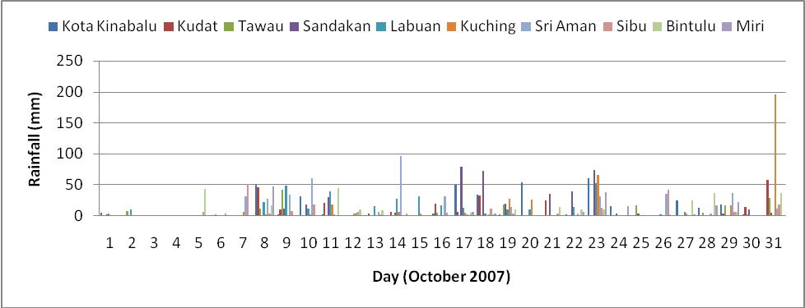

Figure 5e Daily rainfall chart recorded by selected meteorological stations in East Malaysia for October 2007: Typhoon Krosa (1/10/07-08/10/07).

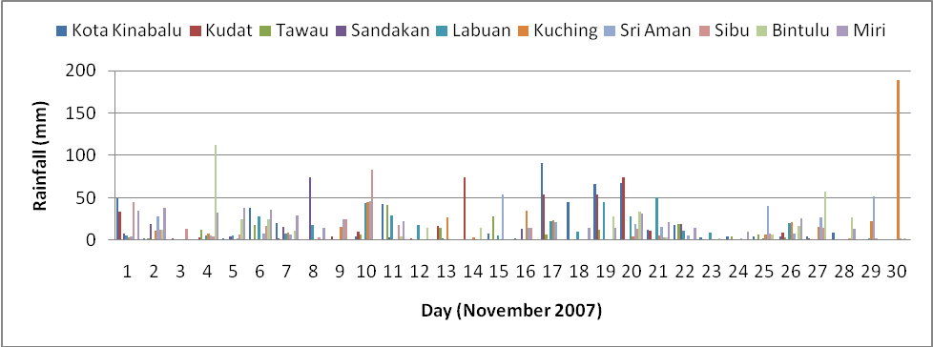

Figure 5f Daily rainfall chart recorded by selected meteorological stations in East Malaysia for November 2007: Typhoon Hagibis (20/11/07-27/11/07).

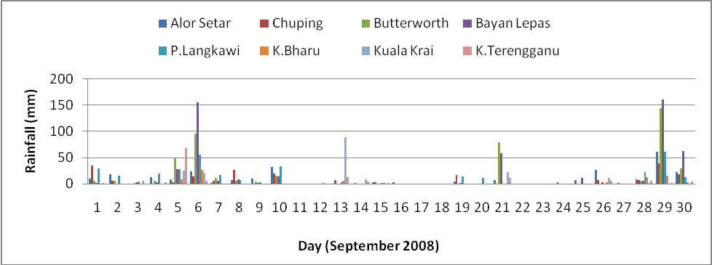

Figure 5g Daily rainfall chart recorded by selected meteorological stations in Peninsular Malaysia for September 2008: Severe Tropical Storm Mekkhala (29/09/08-30/09/08).

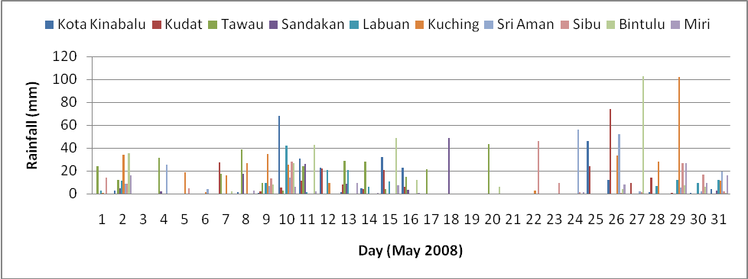

Figure 5h Daily rainfall chart recorded by selected meteorological stations in East Malaysia for May 2008: Typhoon Rammasun (07/05/08-13/05/08).

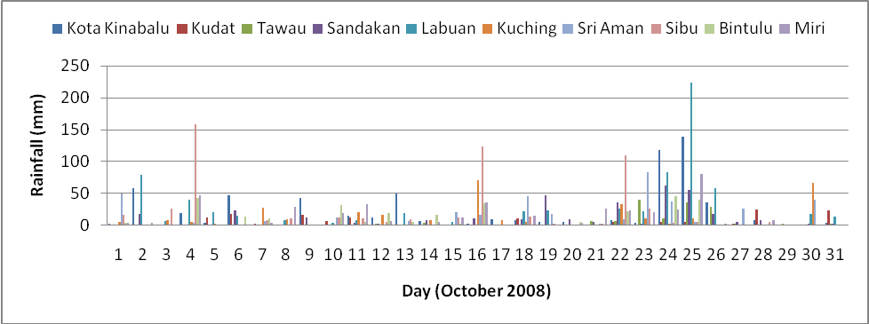

Figure 5i Daily rainfall chart recorded by selected meteorological stations in East Malaysia for October 2008: Tropical Storm Higos (30/09/08-04/10/08).

1.2 Hydrological Assessment

During the 2007 North-East monsoon, the northern and east region of the Peninsular Malaysia namely Kedah, Kelantan, Pahang and some part of Johor experienced severe flood due to prolong heavy rainfall events. However, the worst floods occurred in the Pahang river basin in the district of Temerloh, Pekan, Rompin, Mentakap and Kuantan for almost two weeks. Meanwhile, the Golok river basin in Kelantan experienced with floods in the period of 18-28 December 2007. Table 5 shows summary of flood occurrences in 2007 north-east monsoon. Figure 6(a), 6(b) and 6(c) shows the respective flooded areas in the Johor, Pahang, and Kelantan river basin that derived using Radarsat earth observation satellite during the period mentioned.

Table 5 Summary of flood events in 2007 North-East Monsoon

State/River Basin | Period of Rainfall  (Dec. 2007) | Date of Peak Flood (2007) | Average Rainfall  (mm) | Highest  Recorded Daily Rainfall  (mm) | Estimated Area of Flood Extent (Hect.)
Muda River, Kedah | 5-17 | Dec. 20/26.10m @ Jeniang | 199 | 135 | -
Golok River, Kelantan | 5-21 | Dec. 16/10.63m @ Rantau Panjang | 801 | 420 | 45,000
Pahang River, Pahang | 5-15 | Dec. 12/54.28m @ Sg. Yap  Dec. 13/34.02m @ Temerloh  Dec. 15/22.47m @ Lubok Paku | 385 | 261 | 36,000
Muar River, Johor | 5-22 | Dec. 10/11.94m @ Segamat  Dec.12/10.20m @ Buloh kasap | 398 | 217 | 40,000

The estimated total cost of the flood damages is RM316 million. Approximately 36,143 people were evacuated and given shelter in relief centres in Pahang and Kelantan. The death toll during this flood was 22 persons. The worst affected areas were areas along major rivers such as Sg Pahang, Sungai Muar and Sungai Golok.

Figure 6(a) Flood Extent Map of Johor

Figure 6(b) Flood Extent Map of Pahang

Figure 6(c) Flood Extent Map of Kelantan

- 2.0 Summary of progress in Key Result Areas

- 2.1 Reduced Loss of Life from Typhoon-related Disasters.

2.1.1 Meteorological Achievements/Results

JMA-MMD Storm Surge Model

Malaysian Meteorological Department (MMD) with the consent of Japan Meteorological Agency (JMA) runs a JMA Storm Surge Model on operational mode since July 2007. It simulates and predicts storm surges mainly caused by tropical cyclones.

With the aid of the model, MMD successfully predicted sea level rise (25 – 27 November 2008) over the coastal areas of Sabah due to strong winds arising from typhoon Hagibis (Figure 7) in the South China Sea.

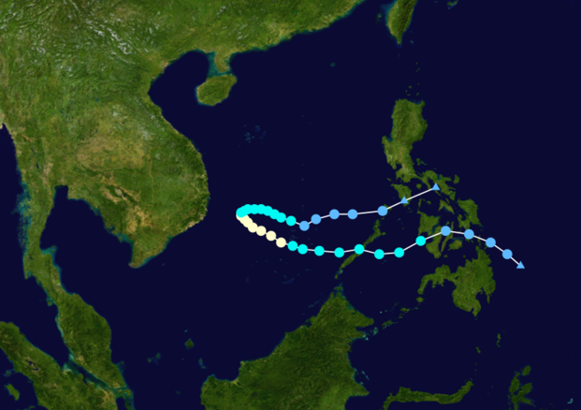

Figure 7 Track of Typhoon Hagibis.

2.1.2 Hydrological Achievements/Results

Improvement of Facilities

The Department of Irrigation and Drainage (DID) to date has installed about 362 telemetric stations in 38 river basins. A total of 405 manual river gauges and 1019 stick gauges in flood prone areas have been set up to provide additional information during the flood season. As part of the local flood warning system, about 300 automatic flood warning sirens and 154 flood warning boards are being operated. Of this a total of 103 stations have been installed this year which comprises 18 new telemetry stations for the 15 states; and about 88 new telemetry stations are being developed for the Klang valley Integrated Flood Forecasting and Warning System (SERBAN).

To implement the SERBAN project that comprises the infrastructure networks and flood modelling system, cost involved is about RM30 million. Briefly, the flood modelling system covers the development of hydrometeorology and hydrodynamic modelling system that include GIS component and the generated flood risk map. To date, about 90% of physical works on the infrastructure networks completed; however the modelling part reached about 20% progress.

As reported previously, Kuala Lumpur Stormwater and Management Road Tunnel Project (SMART) had completed and successfully operated. Since SMART began operation in July 2007, it had successfully diverted flood water from upstream Klang River at Kampong Berembang for more than 40 times. During this period, there were at least 4 major storm events where the diversion of excess flood water by the SMART system had saved Kuala Lumpur city centre from the impact of flooding.

The Kuala Lumpur City Centre, Shah Alam, Petaling Jaya, major highways, light transportation system, high density populations were among the major features in the catchments. Hence the efficient and accurate flood forecast is an important consideration that should be taken in order to combat the flood in the catchments.

2.1.3 Research, Training, and Other Achievements/Results

Training Attachment at the Japan Meteorological Agency (JMA)

To further improve and enhance the capability in predicting storm surges due to tropical cyclones as well as wave modelling and forecasting, an MMD officer was sent for attachment training at the JMA from 3 – 28 November 2008. During the training, the officer will learn about validation of the storm surge forecast with sea level observation, Ensemble Storm Surge forecast (5 members) using the output from MM5 or WRF as forcing fields, and wave and oil spill modelling. MMD will be given the wave and oil spill programs to be implemented for operational purposes. MMD also plans to invite the JMA experts to Malaysia in early 2009 to conduct training workshop for MMD staff.

2.2 Minimized Typhoon-related Social and Economic Impacts.

2.2.1 Meteorological Achievements/Results

PRECIS (Providing Regional Climate for Impacts Studies)

The PRECIS model is being run at the Malaysian Meteorological Department and National University of Malaysia to understand the impacts of various climate change scenarios for the 21st century over the South East Asian region. Lateral boundary data of the future projection scenarios presently available for PRECIS are the HadCM3 ocean-atmospheric coupled projection (A1B scenario) and the HadAM3P atmospheric only (B2 ad A2 scenarios) projection. Further modifications are being done to PRECIS in order to accommodate ECHAM5 lateral boundary data from the Max Planck Institute in Germany.

MMD also has participated actively on sharing of completed PRECIS Southeast Asian regional simulation output/results among the researchers from ASEAN member countries.

MMD has conducted sensitivity analysis of AOGCM projections to derive regional climate change scenarios over Southeast Asia Region using 9 AOGCMs output data obtained from IPCC Data Distribution Centre.

2.2.2 Hydrological Achievements/Results

Flood Forecasting and Warning (basin in operation)

Flood forecasting operations were carried out during the flood seasons by the respective DID state offices with technical assistance from the National Flood Forecasting Centre at DID Headquarter. The river basins which have been provided with forecasting models are summarized in Table 6.

Table 6 The river basins with forecasting models.

River Basin | Catchments Area  (km²) | Number of Forecasting Point | Forecasting Model
1. Muda River | 4,300 | 2 | Stage Regression
2. Perak River | 14,700 | 3 | Stage Regression
3. Muar River | 6,600 | 2 | Linear Transfer Function
4. Batu Pahat River | 2,600 | 2 | Stage Correlation
5. Johor River | 3,250 | 2 | Regression Model
6. Pahang River | 29,300 | 3 | Linear Transfer Function and Stage Regression (back-up)
7. Kuantan River | 2,025 | 1 | Tank Model
8. Besut River | 1,240 | 1 | Stage Regression
9. Kelantan River | 13,100 | 2 | Tank Model and  Stage Regression  (back-up)
10. Golok River | 2,175 | 1 | Stage Regression
11. Sadong River | 3,640 | 1 | Linear Transfer Function
12. Kinabatangan River | 17,000 | 1 | Linear Transfer Function
13. Klang River | 1280 | 5 | Flood Watch

Some of the flood forecasting models were being revised in the middle of the year with a view to evaluate their performance and subsequently to make necessary improvement where and when necessary; for instance Johor River, Muar River and Batu Pahat River, using the real time computerized HEC-HMS.

2.2.3 Disaster Prevention and Preparedness Achievements/Results

National Security Council (NSC) and MMD had participated in "The 3rd Typhoon Committee Working Group Meeting for Disaster Prevention and Preparedness on Typhoon Committee Disaster Information System and Future Activities" in Seoul, Korea and had contributed actively in the discussion.

2.2.4 Research, Training, and Other Achievements/Results

MMD had participated in the "Integrated Workshop on Coping with Climate Change in Typhoon Committee Area" held in Beijing, China with the purpose to assess and mitigate the possible social-economic impacts of climate change to the Typhoon Committee Area.

MMD also had two (2) officers going through "Temporary Attachment at Japan Meteorological Agency (JMA) for Climate Forecasting and its Applications" training.

2.2.5 Identified Opportunities/Challenges for Future Achievements/ Results

PRECIS (Providing Regional Climate for Impacts Studies)

Collaboration at the regional scale in regard to sharing of lateral boundary data and the PRECIS climate model simulation outputs is healthy for the South East Asian Region. This collaboration is one of the outcomes of the PRECIS workshop successfully hosted by MMD from 7-11 of August 2006. Another PRECIS workshop to be held next year in MMD is in the planning stage. The aim of the workshop is to address issues such as base-line validation, information on latest updates to the PRECIS model, sharing of PRECIS climate simulation outputs and application of the various outputs available.

2.3 Improved Typhoon-related Disaster Risk Management in Various Sectors.

2.3.1 Disaster Prevention and Preparedness Achievements/Results

Malaysia is relatively safe from severe disasters such as earthquake, volcanic eruption and typhoon. Major disasters that occurs in Malaysia are north-easterly monsoon floods which occur in December till January of the following year, followed by landslides due to heavy rains or land use at risk area, severe haze and from time to time, man-made disasters. Natural disasters are unavoidable but preventative measures have been worked out in order to mitigate the impact of the disasters.

Disaster Management Application System

The Disaster Management Application System has been introduced to establish a central system for collecting, storing, processing, analyzing, and disseminating value-added data and information to support the relevant agencies in the mitigation and relief activities of disaster management in the country. It enables all government agencies to be well prepared in handling disasters as it provides important data and information about natural disasters.

Beside, it also emphasizes on the utilization of remote sensing technologies, Geographical Information System (GIS) and Global Positioning System (GPS) technologies to provide up-to-date and reliable data to support the three components of disaster management, that are, (i) early warning, (ii) detection and monitoring, and (iii) mitigation and relief for pre, during and post disaster management activities coordinated by National Security Council (NSC) and implemented by relevant authorities.

“999”

999 is the Dedicated Emergency Line of Customer Assistance Service (CAS) by Telekom Malaysia Berhad (TM) to improve the efficiency of public safety agencies in Malaysia. It provides reliable “on-line/real-time” information database of any or all public safety/security activities, records and/or incidents.

999 Response Centre receive the call in 10 seconds, and determines correct Problem Nature and priority. The call will be transfer to the related agencies for immediate response.

Disaster Management and Relief Committee

For the year 2008, the Honourable Deputy Prime Minister of Malaysia, as the chairman of National Disaster Management and Relief Committee, has chaired two flood disaster preparations and mitigation meetings. All disaster management agencies involved would assess and report on their preparedness on emergency response, recovery and rehabilitation for the flood disaster victims.

Similar preparation and mitigation meetings were also held at the state and district levels. The committee is responsible to evaluate a situation and to determine the level and scope of disaster; to formulate plan of action; to determine capability in handling disaster and the need to request for assistance whether from within or outside of the country.

Reviewing the Directive No. 20 of the National Security Council (NSC)

In order to facilitate the management of disaster, NSC is tasked to coordinate efforts among the various agencies involved in disaster management. The Directive No. 20 National Security Council: the Policy and Mechanism on National Disaster and Relief Management was established on 11th May 1997 to bring all agencies together in managing the disaster.

Due to uncertainty and complexity of disaster nowadays conscientious of the expert to review the contents of Directive No. 20 is of high priority. Today, the NSC is taking steps by having meetings at regular intervals with the various agencies to further strengthen the directive to suit the situation.

2.3.2 Research, Training, and Other Achievements/Results

Disaster Management Exercise

Exercises are carried out to ensure high level of responsiveness among the relevant agencies involved in disaster management in areas such as decision-making and implementation of procedures and guidelines. These exercises help to strengthen cooperation and to consolidate effort in multi-agency tasking. Some of the exercises held are as follows:

i. Disaster and Crisis Management Exercise in Various Field.

--- Malaysia Gas Exercise on 12th June 2008 at Alamanda Surrounding, Putrajaya.
--- Ex Sebukor 08 on 23rd -24th April 2008 at Melaka.
--- “Sayap Hangus” Disaster Exercise on 26th June 2008 at Labuan.

ii. Nuclear, Biological and Chemical Exercise.
--- Oil Spill Fighting Exercise National Level 2008 at Sarawak and Terengganu.

iii. Influenza Pandemic Simulation Exercise.
--- Influenza Pandemic Simulation Exercise among the Ministry/Department (SIMEX 2008) on 1st July 2008 at Ministry of Health Malaysia, Putrajaya.

iv. Tsunami Emergency Drill.
--- The Tsunami Emergency Drill was held on 17 December 2007 at Langkawi. It was an integrated tsunami emergency plan for Kuala Teriang, Kampung Kuala Melaka dan Kampung Batu Ara, Mukim Padang Maksirat in Langkawi.

2.3.3 Regional Cooperation Achievements/Results

Regional Cooperation

At the regional level, Malaysia is an active member of the Association of South East Asia Nations (ASEAN) and is a member of the ASEAN Committee on Disaster Management (ACDM). In ensuring cooperation among Member States, the ASEAN Agreement on Disaster Management and Emergency Response (AADMER) was signed on 26 July 2005. Malaysia was among the first countries to ratify AADMER together with Cambodia, Lao PDR, Indonesia, Myanmar, Thailand and Vietnam.

In line with the Agreement, in the coordination of disaster relief, Member States are called upon to designate National Focal Point and competent authorities to support the establishment of ASEAN Coordinating Centre for Humanitarian Assistance on disaster management (AHA) as well as to support the ASEAN Standby Arrangements for Disaster Relief and Emergency Response. The standby arrangements allow Malaysia to earmark assets on voluntary basis to be shared with other Member States in need of assistance.

2.4 Strengthened Resilience of Communities to Typhoon-related Disasters.

2.4.1 Hydrological Achievements/Results

Technical Advancement

The InfoBanjir website (http://infobanjir.water.gov.my) continues to be enhanced and improved in terms of IT technology, hardwares, procurement and network expansion as well as its contents to meet the customer’s requirement.

2.4.2 Disaster Prevention and Preparedness Achievements/Results

National Disaster Relief Trust Fund (NDRF)

National Disaster Relief Trust Fund was changed from fund to trust fund in 2005 where public and private also can contribute to help in need victims of various disasters. The allocations are annually from the government and contribution from public and private sectors. The types of assistance provided are such as: i) Loss Income; ii) Damaged House; iii) Agriculture, Livestock and Aquaculture Damage; iv) Casualty Expenses; and v) Devastated House.

For the year 2008 Malaysia has contributed about USD 3 million to help the disaster affected countries such as Bangladesh, People Republic of China and Myanmar. The assistances were in term of cash money, medicines, medical equipments, tents and daily necessaries goods.

2.4.3 Research, Training, and Other Achievements/Results

Enhancement of Public Education and Awareness

NSC in collaboration with MMD had conducted five (5) series of public and media awareness programmes through out October and November 2008 in different states to enhance the public and media understanding of tsunami, earthquake and extreme weather disasters. The objectives of organizing the public and media awareness programmes are to enhance understanding, knowledge and capacity among the public and media regarding early preparedness towards tsunami, earthquake and extreme weather disasters, and to strengthen the emergency responses among the government agencies and non-government agencies.

Beside that, this program was designed to introduce the targeted group the availability of Malaysian Tsunami Early Warning System, its function and the location of the system. The public education program on disasters prevention to people living in flood prone area, was implemented to protect human lives and property; minimizing or to avoid social disruption and economic losses.

2.4.4 Regional Cooperation Achievements/Results

Third Asian Ministerial Conference on Disaster Risk Reduction

Malaysia will be hosting the Third Asian Ministerial Conference on Disaster Risk Reduction in Kuala Lumpur on 2nd-4th December 2008. The conference which consists of pre-conference events, intergovernmental segments and side events will provide the opportunity to the Asian Countries as well as the Pacific nations to share on various outcomes of regional and sub-regional cooperation, to share on multi-stakeholders partnership and to share and exchange on good practices and lessons learned in line with the adopted Hyogo Framework for Action 2005-2010, in building disaster resilient communities. The conference theme is “Multi-Stakeholder Partnerships: From National to Local”.

2.5 Improved Capacity to Generate and Provide Accurate, Timely, and understandable Information on Typhoon-related Threats.

2.5.1 Meteorological Achievements/Results

Hardware and Software Upgrade

Hardware and software upgrades were done this year to the operational numerical weather prediction system at MMD. In addition to the previous 40 single-core AMD processor clusters, two (2) SGI 4700 Altix shared memory systems each with 128 dual-core Intel Itanium processors were acquired. The two systems are being used to run the MM5 and WRF models respectively with the smallest domain having a horizontal resolution of 4 km.

2.5.2 Research, Training, and Other Achievements/Results

Research

The current on-going research activities at MMD include "Diagnostic Study of Heavy Rainfall Episodes over the Malaysian Region during the Northeast Monsoon Season". The objective of this study is to examine the precursors and maintenance of heavy rainfall episodes over the east coast of Peninsular Malaysia and Sarawak during the Northeast Monsoon season from November to February. Rainfall records from 1951 to 2008 are examined. Reanalysis grided NCEP data, ERA40 data from ECMWF and JRA data from JMA are analyzed to study the evolution of vorticity, divergence, vertical motion and potential vorticity fields as well as the equatorward propagation of the cold surges in triggering monsoon disturbances over the south South China Sea and subsequently causing heavy rainfall over the coastal areas of east coast of Peninsular Malaysia and Sarawak.

The other on-going research activity is to study "The Impact of Tropical Storms in the Western Pacific Ocean and South China Sea on the Rainfall in Malaysia". Tropical storms best track data (1951-2007) from RSMC, Tokyo and daily rainfall data from MMD main meteorological stations are used to examine the role of tropical storms on the weather. The tropical storms data investigated include information on the storms position, storms central pressure, 10-minute maximum sustained wind speed, and the different stages of tropical storms intensity.

The active on-going projects carried out by DID are as follows:

i. Sg. Kerayong Urban Hydrology Study funded by the Intensified Research Priority Areas (IRPA)
ii. Flood Diversion (Keruh Diversion, Gombak Diversion etc.)
iii. Detention Pond (Sri Johor, Taman Desa, Batu, Jinjang etc.)

Training

MMD had participated actively in many international trainings, workshops, seminars and symposium, including those related to typhoons, disaster management and floods, as listed below:

i. International Training Course on Weather Modification WMO Regional Training Centre (RTC) in Nanjing, China.
ii. Training Course on Automatic Weather Station Network Hong Kong in Hong Kong, China.
iii. WMO International Symposium on Public Weather Services (PWS): a Key to Service Delivery in Geneva, Switzerland.
iv. The International Training Workshop for Typhoon and Flood Disaster Reduction in Taipei,Taiwan.
v. Regional Numerical Weather Prediction Training Workshop in Langen, Germany.

In an effort to improve understanding of the data assimilation processes in the numerical weather prediction model, a MMD officer was having a training attachment with the Numerical Weather Prediction Division of the Korea Meteorological Administration. The model of interests is the Weather Research and Forecasting (WRF) model.

The courses related to flood and hydrology organized by DID during the year are as follows:

i. A course on “Configuring an Operational Flood Forecasting System based on the Tank Model”, Regional Corporation Project Implementation Plan (RCPIP), Working Group Of Hydrology, Typhoon Committee, Kuala Lumpur. The first course had been conducted on 21 January 2008 – 28 Febuary 2008. While the second course will be held on 1 - 31 December 2008.
ii. A course on “Flood Mitigation for Engineers”, Kuala Lumpur, 17 - 19 Mac 2008.
iii. A course on “Hydrological Application for Engineers”, Kuala Lumpur, 25 - 27 Mac 2008.
iv. A course on “Flood Forecasting Application for Engineers”, Kuala Lumpur, 1 - 3 April 2008.
v. A course on “Hydraulics and Catchments Modeling for Engineers”, Kuala Lumpur, 21 – 24 April 2008.

vi. A course on “Flood Mitigation for Supporting Officers”, Kota Bharu, Kelantan, 8 – 10 April 2008.

Information and Communication Technology (ICT)

In 2007, MMD had installed proxy servers in six (6) of its Regional Forecast Office (RFO) with firewalls to enhance the network security. The servers are also equipped with two (2) internet lines (one streamyx and one leased-line) to reduce downtime. Some of the RFO communication lines' speed also upgraded from 256kbps to 512kbps to improve messages exchange between RFO and the MMD headquarter so that timely weather forecasts and severe weather as well as strong winds and rough sea warnings could be issued.

Surface Observation Station

MMD has thirty-nine (39) surface observation stations. Currently, under the 9th Malaysia Plan, MMD is underway to expand the Automated Weather Observing System (AWOS) coverage to increase the intensity of meteorological data over the country by implementing 108 more AWOS stations throughout the country during the year 2008 and 2009.

- 3.0 Resource Mobilization Activities

In the month of December 2007, a few states were affected by severe flood such as Johor, Pahang, Kelantan, Terengganu, Negeri Sembilan in Peninsular Malaysia and Sarawak in East Malaysia. About 19,800 families or 79,800 people had received services provided by various government agencies and NGOs as a disaster victim in evacuation centres or at their relatives' houses.

Every year just before the northeast or winter monsoon, the Department of Social Welfare with other government agencies prepare the necessary facilities to cater for the need of the victims if the disaster occur such as:

i. Identified and prepared the evacuation centre. The current total number of centres are 4,595 which can cater for 1.4 million victims at any one time;

ii. Set up 590 centres at strategic places for storage of food, clothing and personal hygiene necessities;

iii. Localize training activities are organized for officers from the Department of Social Welfare and local volunteers to work in disaster management guided by Standard Operational Procedure (SOP).

- 4.0 Update of Members’ Working Groups representatives

- i. Working Group on Meteorology

Mr. Saw Bun Liong
Director, Central Forecast Office
Malaysian Meteorological Department
Jalan Sultan
46667 Petaling Jaya, Selangor
Malaysia
Email: sawbl@met.gov.my

ii. Working Group on Hydrology

Mr. Hj. Azmi Md. Jafri
Deputy Director
Hydrology and Water Resources Division
Department of Irrigation & Drainage
Km. 7, Jalan Ampang
68000 Ampang
Kuala Lumpur
Malaysia
Email: azmijafri@water.gov.my

iii. Working Group on Disaster Prevention and Preparedness

Datuk Che Moin bin Umar
Under Secretary
Disaster and Crisis Management Division
National Security Council
Aras G, Blok Barat
Bangunan Perdana Putra
62502 Putrajaya
Malaysia
Email: moin@bkn.jpm.my

iv. Training and Research Coordinating Group

Dr. Wan Azli Wan Hassan
Director, Technical Development Division
Malaysian Meteorological Department
Jalan Sultan
46667 Petaling Jaya, Selangor
Malaysia
Email: wanazli@met.gov.my

v. Resource Mobilization Group

Mr. Inau Edin Nom
Director
Social Economy Development & Financial Assistant Division
Department of Social Welfare Malaysia
9-24 Floor, Menara Tun Ismail Mohamed Ali
Jalan Raja Laut
50562 Kuala Lumpur
Malaysia
Email: inau@jkm.gov.my

