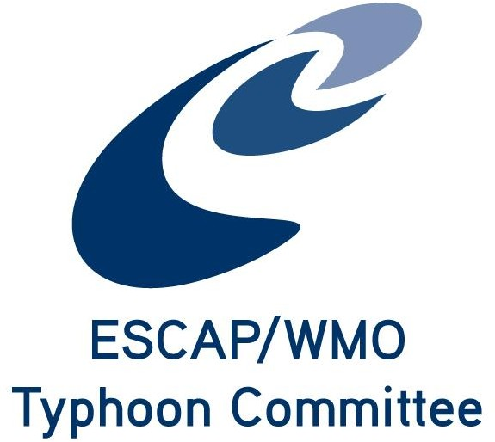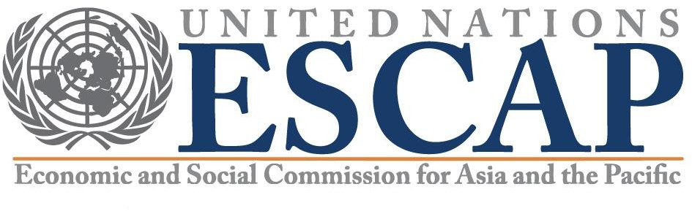

TRCG Parallel Meeting

Typhoon Committee 16th Integrated Workshop (IWS)
2-3 December 2021
Video Conference

The Parallel Session of TC Working Group will be held on 02 December, the Day 1 afternoon of 16th IWS

Convener: Mr Wai-Kin Wong (TRCG Chair)

TRCG Meeting Programme (Tentative):

14:00 – 14:15: Opening and Members’ introduction

14:15 – 15:15: TRCG Report
- Summary of TRCG Activities in 2021
- Review of AOP 2021
- TCTF budget allocation in 2021 and request for 2022.
- Other issues

15:15 – 16:45: Discussions on Upcoming TRCG Activities
- Collaborative projects with AP-TCRC
- 4th TRCG Forum
- Roving Seminar in 2022
- Other issues
- Group photo

1

